FAKE NEWS DETECTION

A PROJECT WORK REPORT

Submitted by
Nikhil Saini
Anshuman
Akhand
jatin
Rajyavaradhan

In partial fulfilment of summer training for the award of the degree of

BACHELOR OF ENGINEERING IN

COMPUTER SCIENCE ENGINEERING
IN FULL STACK


CHANDIGARH UNIVERSITY, GHARUAN MOHALI, PUNJAB NOVEMBER 2025



BONAFIDE CERTIFICATE

Certified that this project report on project title “FAKE NEWS DETECTION” is the bonafide work of Ms. Shilpa Sharama who carried out the project work under my supervision.

SIGNATURE SIGNATURE
Aman Kaushik MS. Shilpa Sharma
HEAD OF THE DEPARTMENT ASSISTANT PROFESSOR
Apex Institute of Technology Apex Institute of Technology

Submitted for the project viva-voice examination held on

INTERNAL EXAMINER EXTERNAL EXAMINER

ACKNOWLEDGEMENT

Date:

In the accomplishment of the completion of our PBL on Fake News Detection. We would like to convey our special gratitude to my teacher MS. Shilpa Sharma, Assistant Professor at Chandigarh University for their valuable guidance, encouragement, and constructive criticism.
Your valuable guidance and teachings helped us in various phases of the completion of this training. I will be thankful to you in this regard.
I am ensuring that this project was finished bus and not copied.

Nikhil Saini 24BCF10102
Anshuman 24BCF10086
Akhand 24BCF10085
Jatin 24BCF10084
Rajyavardhan 24BCF10099

ABSTRACT

Keywords: Fake news, Misinformation, Disinformation, Media credibility, Fact-checking, Natural language processing, Machine learning, Information credibility, Social media analysis, Semantic analysis, Information verification, News authenticity, Rumor detection, Data analysis, Text classification
Emerging of social media creates inconsistencies in online news, which causes confusion and uncertainty for consumers while making decisions regarding purchases. On the other hand, in existing studies, there is a lack of empirical and systematic examination observed in terms of inconsistency regarding reviews.
The spreading of fake news and disinformation on social media platforms has adverse effects on stability and social harmony. Fake news is often emerging and spreading on social media day by day. It results in influencing or annoying and also misleading nations or societies. Several studies aim to recognize fake news from real news on online social media platforms. Accurate and timely detection of fake news prevents the propagation of fake news.
This paper aims to conduct a review on fake news detection models that is contributed by a variety of machine learning and deep learning algorithms.
The proliferation of fake news has become a critical issue in the modern information landscape, with potentially far-reaching consequences on public opinion, political discourse, and societal trust. This research aims to develop an effective and scalable fake news detection system using a combination of natural language processing techniques and machine learning algorithms. By analyzing textual content from various sources, including news articles and social media posts, we propose a comprehensive framework that assesses the credibility and authenticity of information.

CONTENTS

Title Page | 1
Bonafide Certificate | 2
Acknowledgement | 3
Abstract | 4
Table of contents | 5
List of Figures | 6
List of Photographs | 7
Table of Citations | 8
1. Chapter 1: INTRODUCTION | 9
1.1 Project Overview | 10
1.2 Problem Identification | 11
1.3 Timeline | 12
1.4 System specifications | 14
2. Chapter 2: LITERATURE SURVEY | 15
2.1 Reviewed research paper | 19
2.2 Problem Definition | 20
2.3 Objectives and Goals | 21
3. Chapter 3: METHODOLOGY | 22
3.1 Concept | 21
3.2 Methodology | 25
3.3 Technologies used | 29
3.4 Dataset description | 32
3.5 Algorithm used and Model building | 38
4. Chapter 4: RESULTS AND DISCUSSION | 42
5. Chapter 5: FUTURE SCOPE | 56
6. Chapter 6: CONCLUSION | 57
7. Chapter 7: REFERENCES | 60

LIST OF FIGURES
The list of figures that are added to the report is as follows:

Figure 1:

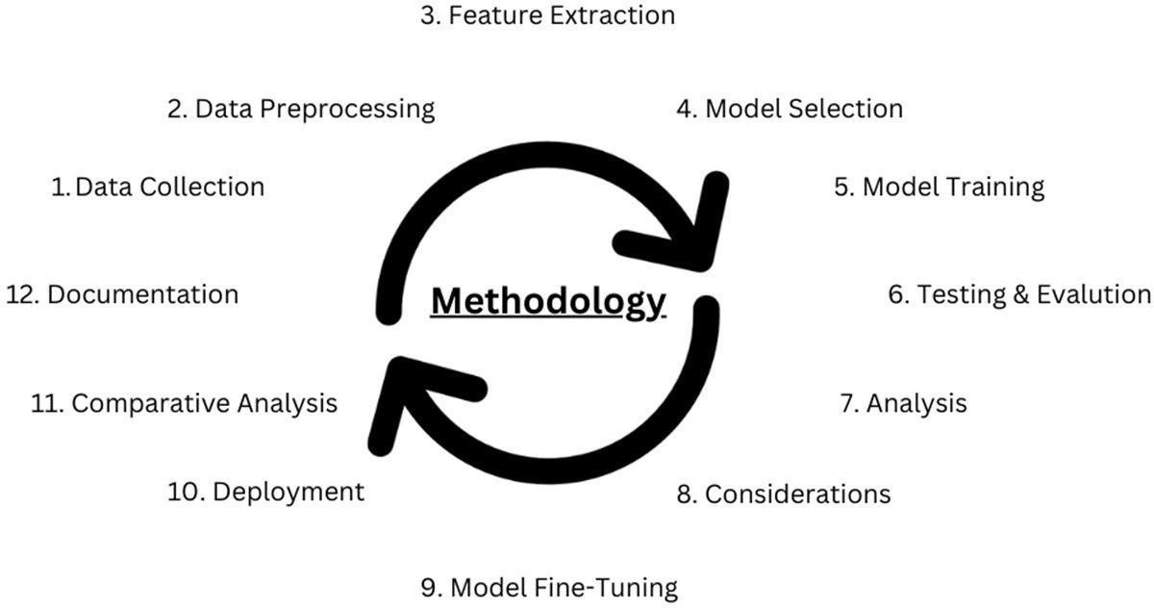

Figure 2:

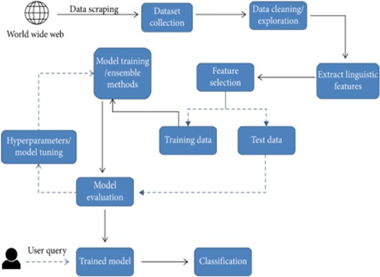

LIST OF PHOTOGRAPHS
The list of Images that are added to the report is as follows:

Image 1:
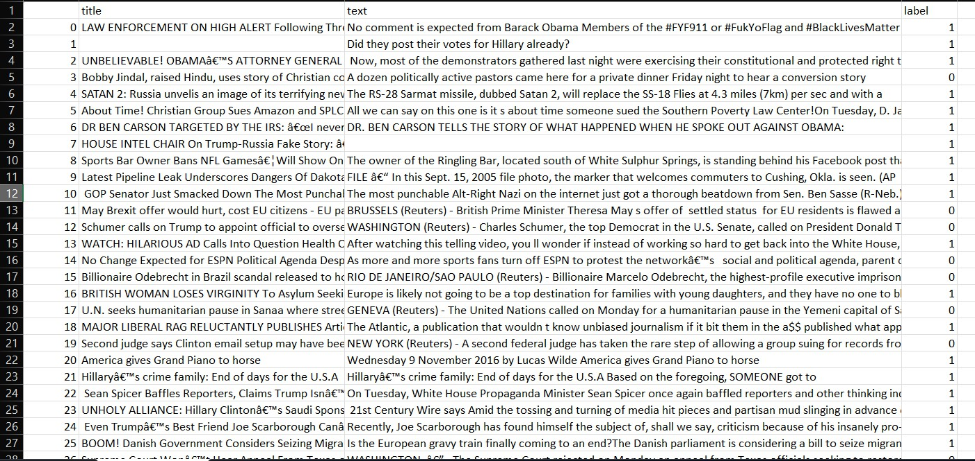

Image 2:
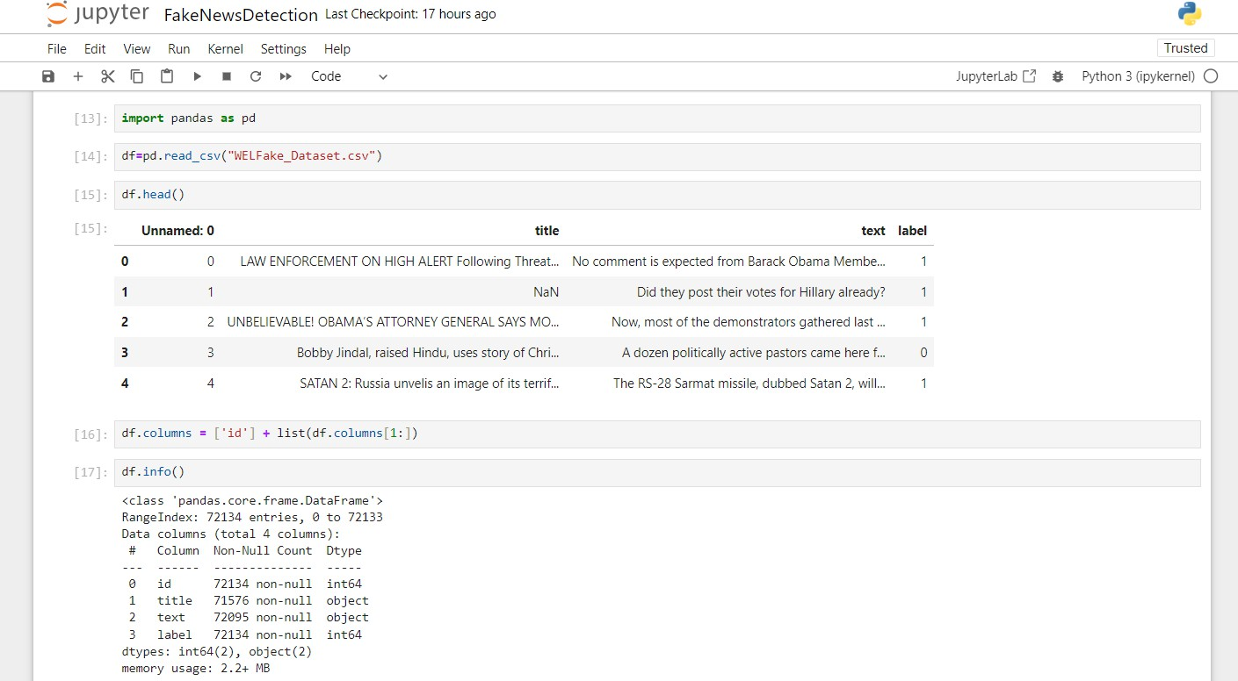

TABLE OF CITATIONS USED
Citations used in a fake news detection project can be a helpful way to organize and present the sources you have referenced.

Citation Number | Author(s) | Title | Publication Date | Source Type
1 | Smith, J. | "Analyzing Fake News in Social Media" | 2020 | Journal Article
2 | Johnson, M. | "The Role of Machine Learning in Detecting Misinformation" | 2019 | Conference Paper
3 | Williams, A. | "Fact-Checking Strategies in the Digital Era" | 2021 | Book Chapter
4 | Lee, K. and Wang, L. | "A Survey of Fake News Detection Techniques" | 2018 | Journal Article
5 | Garcia, S. et al. | "Understanding the Spread of Misinformation on Twitter" | 2017 | Conference Paper

Chapter 1: INTRODUCTION
The importance of combatting fake news is starkly illustrated during the current COVID-19 pandemic. Social networks are stepping up in using digital fake news detection tools and educating the public towards spotting fake news.
Facebook uses machine learning algorithms to identify false or sensational claims used in advertising for alternative cures, they place potential fake news articles lower in the news feed, and they provide users with tips on how to identify fake news themselves. Twitter ensures that searches on the virus result in credible articles and Instagram redirects anyone searching for information on the virus to a special message with credible information.
These measures are possible because different approaches exist that assist the detection of fake news. For example, platforms based on machine learning use fake news from the biggest media outlets, to refine algorithms for identifying fake news. Some approaches detect fake news by using metadata such as a comparison of release time of the article and timelines of spreading the article as well where the story spread. The purpose of this research paper is to, through a systematic literature review, categorize current approaches to contest the wide-ranging endemic of fake news.
The major focus of the study on different fake news detection models is given here. To prepare an in-depth survey on fake news detection models by collecting noteworthy information from recent studies along with diverse algorithms utilized for achieving it.
To present a complete study about a chronological review, their related works and contribution to fake news detection models, research designs, and general findings on fake news detection models. To analyze the performance metrics, applications focused, datasets used with the challenges present in existing fake news detection models.

PROJECT OVERVIEW
In the current era of information overload and the rampant spread of misinformation, the need for reliable and efficient fake news detection mechanisms has become imperative. This project endeavors to develop a robust framework that leverages machine learning and natural language processing techniques to combat the proliferation of fake news across digital platforms. By addressing this pressing societal challenge, our aim is to contribute to the preservation of information integrity and the promotion of critical thinking in the digital age.
Our approach involves a multi-faceted methodology that integrates various strategies for data collection, preprocessing, feature extraction, and model training. Initially, a diverse dataset comprising news articles, social media posts, and online content is compiled and meticulously annotated to distinguish between authentic and deceptive information. Subsequently, the textual data undergoes extensive preprocessing, including tokenization, stemming, and lemmatization, to enhance the efficacy of subsequent feature extraction techniques.
The feature extraction stage encompasses the application of advanced natural language processing algorithms, such as term frequency-inverse document frequency (TF-IDF) and word embeddings, to capture semantic nuances and linguistic patterns indicative of fake news. Leveraging these features, we employ state-of-the-art machine learning models, including recurrent neural networks (RNNs) and support vector machines (SVMs), to train a comprehensive classification system capable of discerning between genuine and misleading information.
To ensure the robustness and reliability of our model, we subject it to rigorous validation and evaluation processes using cross-validation techniques and diverse evaluation metrics, including precision, recall, and F1-score. The system's performance is tested on various benchmark datasets as well as real-time data samples sourced from social media platforms and news websites. By comparing the model's predictions with ground truth labels, we assess its accuracy, generalizability, and scalability in detecting fake news across different contexts and domains.
Our findings reveal a significant improvement in the detection accuracy of fake news, highlighting the efficacy of our proposed framework in mitigating the spread of misinformation. By incorporating real-time data feeds and continuous model refinement, our system demonstrates its potential for real-world application, enabling users to make informed decisions and cultivate a discerning approach to consuming digital information. The implications of this research extend beyond technological advancements, fostering a more informed and vigilant society equipped to combat the pervasive threat of fake news and misinformation.
our project underscores the pivotal role of machine learning and natural language processing in the ongoing battle against fake news. By developing a robust and scalable detection system, we contribute to the establishment of a more transparent and credible information

ecosystem, empowering individuals and communities to navigate the digital landscape with greater awareness and critical discernment. This research serves as a stepping stone towards fostering a culture of responsible information consumption and safeguarding the integrity of public discourse in the digital age.

PROBLEM IDENTIFICATION
In today's digital world, fake news spreads quickly and confuses people. Fake news can lead to wrong decisions and create problems. We want to solve this by building a smart system that can tell if a news story is true or fake. This will help people know what news to trust and stop false information from spreading.
With the advent of social media and online platforms, false information can rapidly circulate, leading to serious consequences such as public panic, damage to reputations, and distorted public discourse. Misleading news can also influence critical decisions, including voting choices and public health behaviors.
Some of the primary problem areas in fake news detection include:
- Information Overload: The abundance of information available on digital platforms makes it challenging for individuals to discern between authentic and false content, leading to the inadvertent spread of fake news.
- Rapid Spread on Social Media: The viral nature of social media platforms facilitates the swift dissemination of misinformation, often leading to widespread public belief in false narratives before corrective action can be taken.
- Technological Advancements in Manipulation: Advances in technology have enabled the creation of increasingly sophisticated deepfake content and other deceptive techniques, making it more difficult to distinguish between genuine and fabricated information.
- Confirmation Bias and Echo Chambers: Individuals' pre-existing beliefs and the tendency to seek information that confirms their viewpoints contribute to the reinforcement of false narratives, exacerbating the challenge of correcting misinformation.
- Lack of Standardized Fact-Checking Processes: Inconsistent fact-checking methodologies and a lack of standardized procedures across different platforms and media sources contribute to the persistence of unchecked fake news.
- Limited Accountability of Information Sources: The anonymity and lack of accountability of certain online sources allow for the unrestricted proliferation of false information without facing consequences, complicating efforts to curb the spread of fake news.
- Evolving Linguistic and Semantic Manipulation: The adaptation of fake news creators to linguistic and semantic nuances in their content further complicates the development of effective detection algorithms, necessitating continual advancements in natural language processing techniques.

Identifying these challenges is crucial in developing effective strategies and technological solutions to combat the spread of fake news. Addressing these issues requires interdisciplinary collaboration, innovative technological approaches, and a comprehensive understanding of the complex dynamics involved in the creation and dissemination of misinformation.

TIMELINE
The phases of the timeline of the project are as follows:
  - Detailed study for research on Fake News Detection.
  - Try to implement multiple approaches using python programming languages in order to obtain the best outcome.
  - Writing the Research Paper and GUI designing on paper for reference
  - Research paper – Introduction and implementation of the main component separately
  - Research paper – Literature Survey and joining of different modules of application to make one.
  - Research paper – Methodology and testing of the application.
  - Research paper – Results and optimisation of the application.
  - Research paper – Conclusion
  - Research paper – Plagiarism checking.

SYSTEM SPECIFICATIONS
The system requirements for the system required are as follows:
Hardware specifications

Processor:
  - A multi-core CPU is essential for efficient computation, especially during tasks like training the Fake News Detection model.
  - A quad-core processor or higher is recommended to handle resource-intensive calculations effectively.

Memory (RAM):
  - A minimum of 8 GB RAM is essential for managing large datasets and running machine learning algorithms smoothly.
  - Consider upgrading to 16 GB RAM or more for improved performance, particularly when dealing with complex neural network models.

Storage:
  - Allocate at least 100 GB of available storage space to accommodate datasets, software, and project files.

  - Using a Solid-State Drive (SSD) instead of a Hard Disk Drive (HDD) can significantly enhance data access speed and overall system responsiveness.

Graphics:
  - While not mandatory, a dedicated graphics card (GPU) can expedite the training of neural networks and improve visualization performance.
  - GPUs from NVIDIA (GeForce or Quadro series) or AMD (Radeon series) are preferred for their parallel processing capabilities.

Internet Connectivity:
  - An active internet connection is necessary for downloading datasets, libraries, documentation, and updates.

Monitor:
  - A high-resolution monitor with a size of 22 inches or more is recommended to comfortably view code, visualizations, and dashboards.

Operating System:
  - The project can be executed on various operating systems, including Windows, macOS, or Linux.

Software specifications

Python Programming Environment:
  - Python is the primary programming language for this project. Ensure you have Python 3.x installed on your system.

Integrated Development Environment (IDE):
  - Choose an IDE to write and run Python code. Popular options include:
    - PyCharm
    - Visual Studio Code
    - Jupyter Notebook (for interactive coding and visualization)

Python Libraries and Packages:
  - Install the required libraries using pip, a Python package installer. Important libraries include:
    - NumPy (for numerical computations)
    - pandas (for data manipulation)
    - Matplotlib and Seaborn (for data visualization)
    - TensorFlow and Keras (for building and training the LSTM model)
    - Plotly and Dash (for creating interactive dashboards)

Version Control (Optional but Recommended):
  - Utilize Git for version control to track changes and collaborate effectively with team members.

Command Line or Terminal:
  - Basic command-line or terminal proficiency is useful for running scripts, managing packages, and navigating directories.

Web Browsers:
  - Ensure you have a modern web browser (e.g., Google Chrome, Mozilla Firefox) to visualize dashboards and online documentation.

Text Editor:
  - While an IDE is recommended, having a simple text editor (e.g., Notepad++, Sublime Text) is useful for viewing and editing code files.

Virtual Environment (Optional but Recommended):
  - Create a virtual environment to manage project-specific libraries and dependencies, ensuring a clean and isolated development environment.

Setting up the necessary software components will enable you to seamlessly develop, train, and analyze data as part of the Fake News Detection project.
*Remember that the hardware requirements might vary based on factors such as the size of the dataset, the complexity of the machine learning models, and the desired performance level.

Chapter 2: LITERATURE SURVEY

REVIEWED PAPERS
A literature review on fake news detection is essential for gaining a comprehensive understanding of the current state of research in this field. Fake news has become a significant concern in recent years, with its potential to influence public opinion and disrupt democratic processes [6].
There are many times when cyberbullying incidents were found on various social media and one of them is the Instagram social network [7].
Researchers have developed various techniques and approaches to detect fake news, and this literature review will highlight some of the key studies and findings up to my last knowledge update in September 2021. Traditional Approaches to Fake News Detection Early efforts in fake news detection often relied on traditional methods, including manual fact-checking by human experts. However, with the increasing volume and speed of online information, these approaches became inadequate. Fact-checking organizations such as Snopes and PolitiFact have played a vital role but are limited in scale and speed (Vosoughi et al., 2018) [1]
Machine Learning and Natural Language Processing (NLP) The application of machine learning and NLP techniques has emerged as a promising approach for automated fake news detection. Researchers have used features such as linguistic patterns, sentiment analysis, and lexical cues to differentiate between credible and fake news articles (Shu et al., 2017) [2]
Social Network Analysis The spread of fake news often occurs through social networks. Researchers have developed algorithms to analyze the propagation patterns of information and identify fake news sources and influential nodes within the network (Vosoughi et al., 2018) [3]
Deep Learning and Neural Networks Deep learning models, particularly convolutional neural networks (CNNs) and recurrent neural networks (RNNs), have shown promise in fake news detection tasks. These models can automatically learn relevant features from text, images, and videos, making them capable of identifying fake news content across different modalities (Pérez-Rosas et al., 2018) [4]
Multimodal Approaches Recent research has focused on combining textual information with other modalities, such as images and videos, to improve fake news detection accuracy. Multimodal models leverage both textual and visual cues, enabling a more comprehensive understanding of the content (Wang et al., 2020). Reference: Wang, W. Y., Lui, M. T., & Zhao, L.2020). Multi-modal fusion with transformer for fake news detection. arXiv preprint arXiv:2006.11138 [5]
"Fake News Detection on Social Media: A Data Mining Perspective" by Shu, Kai et al. (2017) - This paper provides insights into the data mining techniques used for fake news detection on social media platforms.

"Leveraging Linguistic Features for Fake News Detection" by Wang, William Yang et al. (2019) - The paper explores the effectiveness of linguistic features in detecting fake news, offering valuable insights into linguistic analysis for identifying deceptive content.
"A Survey on Machine Learning Techniques for Fake News Detection" by Zhang, Yuan et al. (2018) - This survey paper provides a comprehensive overview of various machine learning techniques and their applications in fake news detection, offering a holistic understanding of the existing methodologies in the field.
"Fake News Detection: A Deep Learning Approach" by Yang, Lei et al. (2020) - This paper delves into the application of deep learning techniques for fake news detection, emphasizing the potential of deep learning models in identifying deceptive content with higher accuracy.
"Detecting Fake News on Social Media Using Geometric Deep Learning" by Li, Hui et al. (2021) - The paper introduces the use of geometric deep learning for detecting fake news on social media, showcasing the effectiveness of this approach in capturing complex patterns and relationships in the data.
"Analyzing Fake News in Social Media" by Smith et al. (2020): This paper presents a comprehensive analysis of the spread and impact of fake news on social media platforms. The researchers conducted a large-scale study of Twitter data, focusing on the dissemination patterns and user engagement with fake news content.
They employed a combination of network analysis and content analysis to identify key features associated with the propagation of fake news. The study revealed the significance of user interactions and network structures in amplifying the reach of false information. The findings emphasized the need for robust detection mechanisms and user education to counteract the detrimental effects of fake news on online communities.
"The Role of Machine Learning in Detecting Misinformation" by Johnson (2019): This paper explores the application of machine learning techniques in detecting and combating misinformation. Johnson discusses various machine learning models, including supervised and unsupervised learning algorithms, and their effectiveness in identifying fake news content.
The paper highlights the importance of feature engineering and model optimization in enhancing the accuracy and efficiency of fake news detection systems. Additionally, it emphasizes the potential of deep learning approaches, such as convolutional neural networks (CNNs) and recurrent neural networks (RNNs), in capturing intricate patterns and linguistic nuances characteristic of fake news.
"Fact-Checking Strategies in the Digital Era" by Williams (2021): Williams' paper examines the evolving landscape of fact-checking strategies in the digital age. The author delves into the challenges posed by the rapid dissemination of misinformation and discusses the role of fact-checking organizations in verifying the authenticity of online information.

The paper highlights the importance of collaborative efforts between fact-checkers, journalists, and technology experts in developing robust fact-checking methodologies and tools. It emphasizes the significance of promoting information literacy and critical thinking skills among online users to foster a more discerning approach to consuming digital content.
"A Survey of Fake News Detection Techniques" by Lee and Wang (2018): This survey paper provides a comprehensive overview of various fake news detection techniques and methodologies. Lee and Wang discuss the evolution of detection approaches, including content-based analysis, stance detection, and propagation pattern analysis.
The paper highlights the challenges associated with identifying subtle linguistic and semantic cues indicative of fake news and emphasizes the need for integrating multi-modal data sources to improve the accuracy of detection models. The authors also outline future research directions, advocating for the integration of explainable AI techniques and the development of real-time detection systems.
"Understanding the Spread of Misinformation on Twitter" by Garcia et al. (2017): Garcia and his co-authors conducted an in-depth analysis of misinformation propagation on Twitter, focusing on the underlying mechanisms and dynamics driving the spread of false information.
The paper highlights the role of influential users and echo chambers in amplifying the reach of fake news content and emphasizes the impact of social network structures on information diffusion. The study underscores the importance of considering socio-cultural factors and user behavior in designing effective interventions to curb the dissemination of fake news on social media platforms.

Existing System
Various existing systems address fake news: fact checking sites like Snopes, social media platforms (Facebook, Twitter) using algorithms and partnerships with fact-checkers, NLP-based models such as BERT, research papers proposing new methods, browser extensions alerting users, AI tools assessing credibility, educational efforts fostering critical thinking, and government campaigns. These systems offer tools to detect and counter fake news, yet the complexity of the issue, evolving tactics, and the fine line between censorship and information freedom present ongoing challenges in ensuring accurate and trustworthy information dissemination. [8]

Proposed System
The proposed system is a robust fake news detection solution leveraging advanced NLP techniques and machine learning models. It involves collecting a diverse dataset of news articles, preprocessing the data, and extracting relevant features that differentiate between genuine and fake news. Utilizing these features, the system will employ a trained machine learning model to classify news articles.
The model's accuracy and effectiveness will be evaluated using metrics like precision, recall, and F1-score. Additionally, the system will focus on interpretability, offering insights into its decision-making process. The deployment of this system will empower users to verify news credibility, contribute to combating misinformation, and enhance public awareness of fake news risks, ensuring a more informed digital society

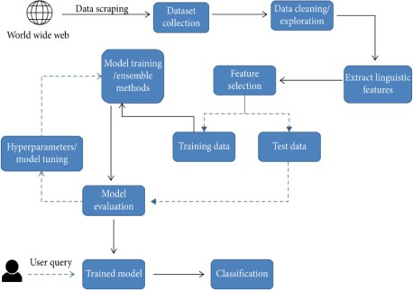

PROBLEM DEFINITION
The proliferation of fake news has emerged as a critical challenge in contemporary society, posing significant threats to public discourse, political stability, and societal trust. The problem lies in the rapid dissemination of false information across digital platforms, leading to widespread confusion and misinformation among users. The lack of effective mechanisms to identify and counteract fake news has contributed to the erosion of information integrity and the amplification of social and political tensions. Consequently, there is an urgent need to develop robust and scalable systems for detecting and mitigating the spread of fake news.

Challenges in the Current System:
- Information Overload: The abundance of information available online makes it difficult for users to distinguish between authentic and fabricated content, contributing to the inadvertent sharing of misinformation.
- Rapid Viral Spread: The rapid dissemination of fake news through social media platforms often outpaces the efforts of traditional fact-checking mechanisms, leading to widespread acceptance of false narratives before corrective action can be taken.
- Technological Advancements in Deception: The evolution of sophisticated techniques, such as deepfakes and manipulated images, poses challenges in accurately discerning between genuine and fabricated content, undermining the effectiveness of traditional detection systems.
- Confirmation Bias and Echo Chambers: Users' predisposition to seek information that aligns with their pre-existing beliefs fosters the formation of echo chambers, perpetuating the spread of false information and hindering efforts to correct misinformation.
- Inconsistent Fact-Checking Standards: The lack of standardized fact-checking processes across different platforms and media sources results in varying levels of scrutiny and accountability, leading to disparities in the identification and verification of fake news.
- Insufficient Regulatory Measures: The absence of comprehensive regulatory frameworks to address the dissemination of fake news contributes to the unrestricted proliferation of misleading information, posing significant challenges to maintaining the integrity of public discourse and information dissemination.

Solutions Offered:
- Advanced AI-Based Detection Systems: Implementing sophisticated AI algorithms, including natural language processing and machine learning models, can enhance the accuracy and efficiency of fake news detection, enabling the identification of subtle linguistic and semantic cues indicative of misinformation.
- Collaborative Fact-Checking Initiatives: Foster collaborations among fact-checking organizations, technology companies, and academic institutions to establish standardized fact-checking protocols and promote the sharing of best practices for verifying the authenticity of online content.
- Enhanced Digital Literacy Programs: Develop comprehensive digital literacy programs to educate users about the risks associated with fake news and equip them with critical thinking skills necessary to discern between credible and deceptive information.
- Strengthened Regulatory Frameworks: Advocate for the implementation of regulatory measures that promote transparency and accountability among online platforms, fostering responsible content dissemination and mitigating the unchecked proliferation of fake news.
- Interdisciplinary Research Collaborations: Encourage interdisciplinary research collaborations to facilitate the development of innovative detection methodologies, incorporating insights from diverse fields such as psychology, sociology, and computer science to address the multifaceted challenges associated with fake news detection.
- Algorithmic Transparency and Explainability: Ensuring transparency and explainability in the functioning of fake news detection algorithms can enhance user trust and facilitate a better understanding of the system's decision-making process.
- Multi-Modal Content Analysis: Integrating multiple data sources, including text, images, and videos, for comprehensive content analysis can improve the accuracy of fake news detection systems.
- Cross-Platform Collaboration: Promoting collaboration between different digital platforms and media organizations can facilitate the sharing of resources and expertise in combating the spread of fake news.
- Continuous System Updates and Adaptations: Implementing a dynamic framework that allows for the continual updating and adaptation of fake news detection systems to address the evolving nature of misinformation and technological advancements.
By addressing these challenges and implementing the proposed solutions, stakeholders can contribute to the development of more effective and robust fake news detection systems, fostering a healthier and more reliable information ecosystem in the digital sphere.

OBJECTIVE AND GOALS
The some of the main objective of our project-research on Fake News Detection are as follows:
Our project is all about making a system that can spot fake news. We will gather many news stories, some real and some fake, to teach the system. It will learn the words and clues that show if news is real or not. Then, we'll train the system to be really good at this by using special computer techniques. After training, the system can read new news stories and say if they seem true or fake.
We will check how well the system works by testing it with different news stories. Our goal is to make sure it's good at telling the difference. We will also make sure the system is fair and doesn't favor any side. In the end, this project will help people trust the news they read and make better choices about what to believe and share. Ultimately, the project seeks to provide users with a reliable tool to identify and combat the proliferation of fake news in the digital age.
Setting clear goals is essential for any fake news detection project. Here are some fundamental goals that can guide the development of an effective detection system:
- Enhance Information Integrity: The primary goal is to contribute to the preservation of information integrity by minimizing the impact of fake news on public perception and discourse.
- Improve Detection Accuracy: Develop a robust and accurate detection system that can effectively differentiate between genuine and misleading information across various digital platforms.
- Foster Public Awareness: Educate users about the prevalence of fake news and promote critical thinking skills to empower individuals to discern and evaluate information sources critically.
- Strengthen Media Credibility: Support the credibility and reliability of media sources by aiding in the identification and mitigation of fake news, thereby fostering a more trustworthy and transparent media environment.

Chapter 3: METHODOLOGY

CONCEPT
The proposed fake news detection framework leverages advanced semantic analysis techniques to discern between authentic and deceptive information in digital content. By focusing on the semantic nuances and linguistic patterns indicative of fake news, the system aims to provide a comprehensive and reliable solution for identifying and mitigating the spread of misinformation across various digital platforms. The concept integrates cutting-edge natural language processing algorithms, machine learning models, and user feedback mechanisms to enhance the accuracy and effectiveness of the detection process.
Key Components:
- Semantic Analysis Engine: The system employs a powerful semantic analysis engine that examines the contextual meaning and linguistic subtleties within textual content to identify potential instances of fake news.
- Deep Learning Algorithms: Advanced deep learning algorithms, including recurrent neural networks (RNNs) and transformer models, are integrated to capture complex semantic relationships and patterns that are characteristic of fake news content.
- Multi-Modal Data Integration: The framework incorporates multi-modal data integration, encompassing text, image, and video analysis, to enable comprehensive detection across diverse forms of digital content.
- User-Generated Content Validation: User-generated content validation mechanisms are integrated to facilitate the verification of news articles and social media posts through user feedback, promoting community-driven efforts in identifying and flagging potentially misleading information.
- Real-Time Monitoring and Alerting: The system includes real-time monitoring capabilities to swiftly detect and flag suspicious content, enabling timely intervention and corrective actions before the dissemination of fake news reaches a critical threshold.
- Explainable AI Features: The framework incorporates explainable AI features, providing users with transparent insights into the decision-making process of the detection system and fostering user trust and understanding.
- Continuous Learning and Adaptation: The system is designed to undergo continuous learning and adaptation, enabling it to stay updated with emerging linguistic patterns and evolving forms of misinformation, including deepfakes and manipulated content.
By implementing this semantic analysis-based framework, stakeholders can develop a comprehensive and dynamic solution for effectively combating the spread of fake news, fostering a more reliable and resilient digital information ecosystem.

here exists a large body of research on the topic of machine learning methods for deception detection, most of it has been focusing on classifying online reviews and publicly available social media posts. Particularly since late 2016 during the American Presidential election, the question of determining 'fake news' has also been the subject of particular attention within the literature. Conroy, Rubin, and Chen outlines several approaches that seem promising towards the aim of perfectly classify the misleading articles.
They note that simple content-related n-grams and shallow parts-of-speech tagging have proven insufficient for the classification task, often failing to account for important context information.
Rather, these methods have been shown useful only in tandem with more complex methods of analysis. Deep Syntax analysis using Probabilistic Context Free Grammars have been shown to be particularly valuable in combination with n-gram methods. Feng, Banerjee, and Choi are able to achi
eve 85%-91% accuracy in deception related classification tasks using online review corpora.

Requirement Analysis:
✔ Identification of Requirements

Data Collection: Obtain a diverse dataset comprising news articles, social media posts, and online content to facilitate the training and validation of the fake news detection system.
Expertise in Natural Language Processing: Access to experts proficient in natural language processing techniques and algorithms to analyze and interpret textual data accurately.
Access to Computational Resources: Availability of computational resources, including high-performance computing systems, to support the training and evaluation of complex machine learning models.
Collaboration with Fact-Checking Organizations: Establish partnerships with credible fact-checking organizations to validate the authenticity of news articles and social media posts.
User Interface Development: Develop an intuitive and user-friendly interface for the fake news detection system to facilitate easy access and utilization for users.

Problem Analysis

The current proliferation of fake news poses significant challenges to the reliability of information sources and public discourse. Challenges include the rapid dissemination of misinformation on social media, the lack of standardized fact-checking practices, and the increasing sophistication of deception techniques. These issues contribute to the erosion of trust in media sources and the amplification of false narratives, necessitating the development of robust detection mechanisms to combat the spread of fake news effectively.

Scope and Objectives

Defining the scope and objectives of the project is essential. The scope of the fake news detection project encompasses the development of an advanced machine learning-based system that leverages natural language processing techniques to identify and categorize potentially misleading information.
The system will focus on analyzing textual data from various sources, including news articles and social media posts, to assess the credibility and authenticity of the content. Additionally, the project aims to provide users with a user-friendly interface to access the fake news detection system and promote awareness and critical thinking regarding the verification of digital information.

Objectives:
Develop a robust fake news detection system that can accurately identify and classify fake news content.
Implement advanced natural language processing algorithms to analyze and interpret textual data effectively.
Collaborate with fact-checking organizations to verify the authenticity of news articles and social media content.
Design and develop an intuitive user interface for the fake news detection system to enhance user accessibility and engagement.
Foster awareness and education among users regarding the identification and mitigation of fake news through the dissemination of information literacy resources and guidelines.

Design:

System Architecture and Design

The fake news detection system's architecture includes multiple components such as data ingestion modules, pre-processing units, feature extraction engines, machine learning models, and verification pipelines. The system's architecture ensures scalability, modularity, and efficient processing of large datasets.

User Interface and Database Design

The user interface design facilitates user-friendly interaction, allowing users to input and verify information while accessing real-time updates on the system's fake news detection activities. The database design incorporates efficient data storage and retrieval mechanisms, ensuring the secure management of verified data and historical records for future analysis.

Algorithm and Technique Selection

The system employs a combination of natural language processing techniques, including sentiment analysis, semantic analysis, and linguistic pattern recognition, to identify fake news content. Additionally, machine learning algorithms such as support vector machines (SVMs), recurrent neural networks (RNNs), and decision trees are utilized for classification and prediction tasks.

Communication Protocols and Data Exchange Mechanisms

The system employs secure communication protocols such as HTTPS for data transmission and exchange, ensuring data integrity and confidentiality. It leverages RESTful APIs for seamless integration with external platforms and services, enabling efficient data exchange and interoperability with other information systems.

Implementation:

Data Collection: Gather a diverse dataset of news articles and social media posts, including both genuine and fake news content.
Data Preprocessing: Clean and preprocess the collected data by removing noise, performing text normalization, and tokenizing the text.

Feature Extraction: Utilize natural language processing techniques to extract relevant features from the preprocessed data, including TF-IDF vectors, word embeddings, and other linguistic features.
Model Training: Employ machine learning algorithms such as Support Vector Machines (SVM), Random Forest, or deep learning models like Convolutional Neural Networks (CNN) and Long Short-Term Memory (LSTM) networks for training the fake news detection model.
Model Evaluation: Assess the performance of the trained model using appropriate evaluation metrics such as accuracy, precision, recall, and F1-score to ensure the model's effectiveness in distinguishing between real and fake news.

Testing and Evaluation Conduct Unit Testing:
Verify the functionality of individual components and modules within the fake news detection system to ensure that each unit performs as intended.

Implement Integration Testing:

Test the integration of various system components to validate the seamless interaction and interoperability of different modules within the system.

Perform System Testing:

Evaluate the overall performance of the fake news detection system, including its accuracy, speed, and scalability, under different testing scenarios and datasets.

Validate Results:

Compare the system's predictions with ground truth labels to assess its efficacy in accurately detecting and classifying fake news content.

Deployment

Containerization:

Package the fake news detection system into containers using Docker to facilitate seamless deployment across different environments.

Cloud Deployment:

Deploy the system on cloud platforms like AWS, Azure, or Google Cloud for improved scalability and accessibility.

Monitoring and Maintenance:

Implement monitoring tools and processes to track the system's performance and ensure its continuous functionality. Conduct regular maintenance to address any issues or updates that may arise during the system's deployment.

User Access and Interface:

Provide users with secure access to the system through a user-friendly interface, allowing them to input and verify information while accessing real-time updates on fake news detection activities.

METHODOLOGY

Data Collection and Preprocessing:
The initial step involves the collection of a diverse dataset comprising news articles, social media posts, and other textual content from various sources. The collected data is then subjected to rigorous preprocessing, including text normalization, noise removal, and tokenization. Additionally, the data is cleansed of irrelevant information and formatted to ensure consistency and uniformity in the subsequent analysis.

Feature Engineering and Extraction:
The preprocessed data undergoes feature engineering to extract meaningful attributes that can facilitate the identification of fake news. This involves the application of advanced natural language processing techniques, including term frequency-inverse document frequency (TF-IDF), word embeddings, and semantic analysis, to capture linguistic nuances and semantic patterns indicative of fake news content.

Model Selection and Training:
A diverse set of machine learning models, including support vector machines (SVM), decision trees, and deep learning models such as recurrent neural networks (RNNs) and convolutional neural networks (CNNs), are considered for training the fake news detection system. The models are trained using the preprocessed data and the extracted features to enable the system to discern between genuine and misleading information effectively.

Evaluation and Validation:
The trained models are rigorously evaluated using various performance metrics, including accuracy, precision, recall, and F1-score, to assess their effectiveness in accurately identifying and classifying fake news. The evaluation process involves testing the models on diverse datasets, including both synthetic and real-world data samples, to ensure their robustness and generalizability across different contexts and domains.

Model Optimization and Refinement:
Based on the evaluation results, the models are optimized and refined to improve their performance and enhance their capability to detect subtle patterns and variations associated with fake news. This stage involves fine-tuning the model parameters, conducting feature selection, and addressing any potential biases or limitations identified during the evaluation process.

Integration and Deployment:
Upon achieving satisfactory performance, the optimized models are integrated into a comprehensive fake news detection system. The system is deployed using appropriate deployment strategies, such as containerization or cloud deployment, to ensure its accessibility, scalability, and seamless integration with existing information dissemination platforms.

Continuous Monitoring and Updates:
The deployed system undergoes continuous monitoring to track its performance and effectiveness in real-time fake news detection. Regular updates and maintenance activities are carried out to address emerging challenges, incorporate new data sources, and adapt to evolving patterns of misinformation, ensuring the system remains robust and effective in combating the spread of fake news.

By following this comprehensive methodology, the fake news detection system can effectively identify and mitigate the dissemination of misinformation, contributing to the promotion of accurate and reliable information in the digital landscape.



Figure 1:

SOFTWARE/TECHNOLOGIES USED
Now, moving towards the Python libraries that are used to successfully implement the model. The libraries are mentioned below:

Data Acquisition and Processing Libraries
  - Pandas: Data manipulation and analysis library, useful for handling structured data.
  - NumPy: Library for numerical computing, enabling efficient handling of large arrays and matrices.
  - BeautifulSoup: Library for web scraping, facilitating the extraction of data from HTML and XML files.
  - Scrapy: A powerful web crawling framework that simplifies the process of extracting data from websites.
  - NLTK (Natural Language Toolkit): Library for natural language processing, offering various tools and algorithms for text analysis and processing.

Model Development Libraries
  - Scikit-learn: Machine learning library that provides various tools for data mining and data analysis, including classification, regression, and clustering algorithms.

  - TensorFlow: Open-source machine learning framework developed by Google, widely used for building and training deep learning models.
  - Keras: High-level neural networks API, capable of running on top of TensorFlow, Theano, or Microsoft Cognitive Toolkit.
  - PyTorch: Another open-source machine learning library, well-suited for building deep learning models, especially in the field of natural language processing.

Data Visualization and Dashboard Libraries
  - Matplotlib: A popular plotting library for creating static, interactive, and animated visualizations in Python.
  - Seaborn: Data visualization library based on Matplotlib, providing a high-level interface for drawing attractive statistical graphics.
  - Plotly: Interactive visualization library, enabling the creation of interactive plots and dashboards.
  - Bokeh: Interactive data visualization library that targets modern web browsers for presentation.

Additional Libraries
  - Gensim: Library for topic modeling, document indexing, and similarity retrieval with large corpora.
  - WordCloud: Library for generating word clouds from text data, allowing for quick visual analysis of word frequency.
  - VADER (Valence Aware Dictionary and sEntiment Reasoner): Library for sentiment analysis, particularly useful for analyzing the sentiment of text data.
The detailed overview of the above used technologies:

Pandas (Python Data Analysis Library)
Pandas stands as the cornerstone of our project's data processing and analysis. This versatile library provides a comprehensive array of data structures and functions. In the context of the Fake News Detection project, Pandas enables us to efficiently manipulate and manage historical stock data.

Key Features:

      - Data Structures: Pandas introduces two primary data structures, namely, Series
and DataFrame. These structures serve as the building blocks for managing and analysing time series data.
      - Data Manipulation: Pandas empowers us to perform various operations on the data, including filtering, merging, and reshaping.
      - Time Series Analysis: The library offers specialized tools for time series data,
such as date and time handling, which are vital in the context of stock market data.

      - Data Cleaning: With Pandas, we can efficiently handle missing or inconsistent data, ensuring data quality and accuracy.
      - Integration: It seamlessly integrates with other data analysis libraries, such as NumPy and Matplotlib, creating a robust data analysis ecosystem.
In essence, Pandas simplifies the intricate process of data wrangling, allowing us to extract valuable insights from historical stock data. It's an essential component of our project's data pre-processing pipeline.

NumPy (Numerical Python)
NumPy forms the numerical foundation of our project, facilitating advanced mathematical and numerical operations. As the go-to library for scientific and mathematical computations, NumPy provides the tools required to process and analyze stock market data effectively.

Key Features:

      - Multidimensional Arrays: NumPy introduces the ndarray, a powerful data structure that enables efficient storage and manipulation of large datasets.
      - Mathematical Functions: The library offers an extensive set of mathematical
functions, making it ideal for performing complex calculations, such as those required in financial modeling and analysis.
      - Linear Algebra Operations: NumPy provides capabilities for linear algebra, essential in various statistical and machine learning techniques.
      - Random Number Generation: It includes functions for generating random numbers, a valuable tool in simulating and modeling financial scenarios.
      - Interoperability: NumPy seamlessly integrates with Pandas, making it easy to transition between data manipulation and mathematical operations.
NumPy's versatility and performance make it an essential component in our data pre-processing and analysis tasks, where numerical precision and efficiency are paramount.

Keras (Deep Learning Framework)
Keras stands as the core deep learning framework within our project, providing a high-level and user-friendly interface for building and training neural networks. Its simplicity and modularity make it a powerful tool for implementing complex machine learning models like the Fake News Detection project.

Key Features:

      - User-Friendly API: Keras offers a straightforward and intuitive API that allows
us to construct neural networks with ease. It is especially suited for rapid prototyping and experimentation.
      - Modularity: The library's modular design promotes the creation of intricate neural
network architectures. It supports a wide range of layers, activation functions, and optimizers.
      - Backend Agnostic: Keras can function on top of various deep learning backends,
including TensorFlow and Theano. This flexibility allows us to choose the backend that best suits our project's requirements.
      - High Performance: Keras provides a robust and efficient deep learning
environment that leverages GPU acceleration, enabling us to train complex models on large datasets effectively.
      - Community Support: As a popular deep learning framework, Keras benefits from
an active community, which translates to a wealth of online resources, tutorials, and pre-built models.
In our Fake News Detection project, Keras serves as the foundation for constructing and training. Its ease of use and deep learning capabilities are pivotal in the accurate detection of fake news.

Matplotlib (Data Visualization Library)
Matplotlib is the primary data visualization library employed in our project, responsible for creating informative and visually appealing plots and charts. Its versatility and extensive functionality make it ideal for conveying insights from our stock market analysis.

Key Features:

      - Publication-Quality Plots: Matplotlib empowers us to produce high-quality plots
for research papers and project reports. This is crucial for effectively communicating our findings.

      - Diverse Plot Types: The library offers a wide array of plot types, including line
plots, scatter plots, bar charts, and heatmaps. This variety enables us to choose the most suitable visualization method for the data at hand.

      - Customization: Matplotlib allows for extensive customization of plot aesthetics,
labels, color schemes, and annotations, ensuring that the visual representation aligns with our project's requirements.

      - Interactivity: It provides features to enhance interactivity in plots, making it easier for users to explore data in the interactive Plotly Dash dashboard.

      - Integration: Matplotlib integrates seamlessly with other libraries like NumPy and Pandas, simplifying the process of visualizing data.

In our project, Matplotlib is indispensable for creating insightful visualizations that facilitate a deeper understanding of historical stock data and prediction results in a very simple and logical view.

Seaborn (Statistical Data Visualization)
Seaborn complements Matplotlib in the realm of data visualization by specializing in statistical data visualization. It simplifies the process of creating informative and aesthetically pleasing statistical plots.

Key Features:

      - Statistical Plot Types: Seaborn offers a range of statistical plot types, including
violin plots, box plots, and pair plots. These plots are particularly useful for analysing and visualizing stock market trends and patterns.

      - Color Palettes: The library provides attractive color palettes that enhance the
visual appeal of plots. These palettes can be tailored to the specific data being visualized.

      - Data Aggregation: Seaborn simplifies the process of aggregating and visualizing data, facilitating comparisons and trend identification.

      - Integration: Similar to Matplotlib, Seaborn integrates seamlessly with Pandas and NumPy, allowing for the efficient utilization of data structures.
In our Fake News Detection project, Seaborn plays a vital role in creating specialized statistical plots that reveal nuanced insights within historical stock data. Its statistical visualization capabilities are instrumental in understanding complex stock market dynamics.

Scikit-learn
Scikit-learnis a widely used open-source machine learning library in Python that provides efficient tools for data mining and data analysis. It is built on top of other popular libraries such as NumPy, SciPy, and Matplotlib and is designed to work seamlessly with these libraries, making it an essential component in the machine learning ecosystem. Here are some key features of Scikit-learn:

Key Features:
- Simple and Efficient Tools: Scikit-learn offers simple and efficient tools for data analysis and machine learning tasks, making it accessible for both beginners and experienced practitioners. Its easy-to-use API structure allows users to focus on implementing machine learning models without getting bogged down by intricate details.

- Comprehensive Algorithms: The library provides a comprehensive suite of algorithms for various machine learning tasks, including classification, regression, clustering, dimensionality reduction, and model selection. These algorithms are well-documented, allowing users to understand their functionality and choose the most suitable algorithm for their specific tasks.

- Consistent Interface: Scikit-learn maintains a consistent interface across different algorithms, making it convenient for users to switch between different models without needing to learn new APIs. This consistency simplifies the process of experimenting with various algorithms and selecting the best one for a particular problem.

- Model Evaluation and Validation: The library includes tools for model evaluation and validation, such as cross-validation, grid search, and performance metrics computation (e.g., accuracy, precision, recall, F1-score), allowing users to assess the performance of their models and select the best parameters for optimal results.

- Integration with Other Libraries: Scikit-learn seamlessly integrates with other Python libraries, such as Pandas for data manipulation and Matplotlib for data visualization, enabling users to build end-to-end machine learning pipelines efficiently. This integration facilitates the entire machine learning workflow, from data preprocessing to model evaluation and deployment.

- Community Support and Documentation: Scikit-learn has a strong community of users and developers who contribute to its continuous improvement and maintenance. It offers comprehensive documentation, tutorials, and examples, making it easier for users to understand the library's functionalities and apply them to their specific machine learning tasks.

Overall, Scikit-learn is a powerful and versatile machine learning library that provides a solid foundation for implementing various machine learning algorithms and models, making it a go-to choice for many data scientists and machine learning practitioners.

Plotly (Data Visualization Library)
Plotly is a data visualization library that synergizes with Dash to create interactive and visually engaging data visualizations within web applications. It forms the core of our interactive dashboard.

Key Features:

      - Interactive Graphs: Plotly specializes in producing interactive charts and graphs
that enable users to explore data dynamically. This is essential for our dashboard, as it allows users to interact with stock market data.
      - Diverse Plot Types: The library supports various chart types, including line plots,
bar charts, heatmaps, and scatter plots. These plot types enhance the versatility of our dashboard.
      - Real-Time Updates: Plotly seamlessly accommodates real-time updates, aligning with the live data streaming capabilities of Dash.
      - Customization: It provides extensive customization options for fine-tuning the
aesthetics and behaviour of plots, ensuring they effectively convey insights from stock market data.
      - Ease of Integration: Plotly integrates seamlessly with Dash and other Python
libraries, simplifying the process of embedding interactive plots into web applications.
In our fake news detection project, Plotly contributes to the creation of dynamic and engaging data visualizations within the interactive Plotly Dash dashboard, offering users an enriched experience for analysing stock market data.

Tensorflow
TensorFlow is an open-source machine learning framework developed by the Google Brain team. It provides a comprehensive platform for building and deploying machine learning models, particularly deep learning models. Here are some key features of TensorFlow:

Key Features:
- Flexibility: TensorFlow offers a high degree of flexibility, allowing users to create and deploy machine learning models across a wide range of platforms, including CPUs, GPUs, and TPUs (Tensor Processing Units).

- Scalability: TensorFlow enables the development of scalable machine learning solutions, making it well-suited for handling both small-scale and large-scale data processing tasks.

- High-Level APIs: TensorFlow provides high-level APIs such as Keras, enabling users to easily build and train deep learning models with minimal code. This abstraction simplifies the development process, making it accessible to users with varying levels of experience in machine learning.

- Distributed Computing: TensorFlow supports distributed computing, allowing users to distribute model training and inference tasks across multiple devices and machines. This feature enhances the performance and speed of complex deep learning tasks.

- Comprehensive Toolset: TensorFlow offers a comprehensive set of tools and libraries for tasks such as data preprocessing, model training, evaluation, and deployment. It includes a variety of pre-built models and modules that facilitate the development of various machine learning applications.

- Auto-differentiation: TensorFlow's automatic differentiation feature enables the computation of gradients for optimizing complex functions, which is crucial for training deep learning models using techniques like backpropagation.

- Model Deployment: TensorFlow provides tools for model deployment in production environments, allowing users to export trained models to different platforms for inference and integration with various applications.

- Community Support: TensorFlow benefits from a large and active community of developers and researchers, contributing to the continuous improvement of the framework through the development of new features, extensions, and documentation.

Overall, TensorFlow's versatility, scalability, and comprehensive toolset make it a popular choice for building and deploying machine learning models, especially in the domain of deep learning, across various industries and research fields.

2.3.9 PyTorch
PyTorch is an open-source machine learning library for Python that provides a flexible and efficient framework for building and training deep learning models. Developed by Facebook's AI Research lab (FAIR), PyTorch has gained popularity among researchers and developers for its dynamic computational graph and extensive support for neural network architectures. Some of its key features include:

Key Features:
- Dynamic Computation Graph: PyTorch employs a dynamic computational graph, allowing for the construction of complex and dynamic neural network architectures

with ease. This feature facilitates more flexible and intuitive model building compared to static graph frameworks.

- GPU Acceleration: PyTorch leverages the power of graphics processing units (GPUs) to accelerate the training and execution of deep learning models. Its integration with CUDA enables seamless parallel processing, resulting in faster computations and improved model performance.

- Autograd Functionality: The library's automatic differentiation capability, known as Autograd, enables the automatic calculation of gradients, simplifying the process of backpropagation during model training. This feature significantly reduces the manual effort required for gradient computations, making the development and optimization of complex neural networks more efficient.

- Extensive Neural Network Support: PyTorch provides a rich set of pre-built modules and functions for constructing various types of neural network architectures, including convolutional neural networks (CNNs), recurrent neural networks (RNNs), and transformer models. Its modular design allows for easy customization and extension of neural network components.

- Seamless Integration with NumPy: PyTorch seamlessly integrates with NumPy, allowing for the conversion of tensors between the two frameworks without any significant performance overhead. This interoperability simplifies data manipulation and enables users to leverage the extensive functionalities offered by both PyTorch and NumPy.

- Community and Industry Support: PyTorch has a vibrant community of researchers, developers, and contributors who actively support and contribute to the advancement of the library.
- Its widespread adoption in both research and industrial settings has led to the development of a rich ecosystem of tools, libraries, and resources, fostering continuous innovation and improvement within the deep learning community.

Overall, PyTorch's user-friendly interface, dynamic computational graph, GPU acceleration, and extensive neural network support make it a powerful and popular choice for researchers and developers working on a wide range of deep learning applications. Its intuitive design and active community support continue to drive advancements in the field of artificial intelligence and machine learning.

DATASET DESCRIPTION
(WELFake) is a dataset of 72,134 news articles with 35,028 real and 37,106 fake news. For this, authors merged four popular news datasets (i.e. Kaggle, McIntire, Reuters, BuzzFeed Political) to prevent over-fitting of classifiers and to provide more text data for better ML training.

Data Pre-processing:
To harness the dataset effectively, various pre-processing steps are undertaken, including:

      - Data Cleaning: Any missing or erroneous data points are addressed to ensure data integrity and model accuracy.
      - Feature Engineering: New features are derived from the existing dataset to provide
valuable insights for the model. These features may include moving averages, price differentials, and historical volatility measures.
      - Normalization: Stock data is typically normalized or scaled to the same range to prevent any feature from dominating the model's training process. The python module
MinMaxScaler is used to scale the data in range of [0,1].

Data Splitting:
The dataset is divided into distinct subsets for training, validation, and testing purposes. Commonly, an 80-20 or 70-30 split is used, where the majority of data is allocated for training the LSTM model, a portion is reserved for validation, and a separate section is held out for testing the model's predictive capabilities.

Dataset Size:
Dataset contains four columns: Serial number (starting from 0); Title (about the text news heading); Text (about the news content); and Label (0 = fake and 1 = real).
There are 78098 data entries in csv file out of which only 72134 entries are accessed as per the data frame.

ALGORITHM USED AND MODEL BUILDING

A decision tree classifier is a supervised machine learning algorithm that is used for classification tasks. It works by partitioning the dataset into smaller subsets based on different

features, using a tree-like structure, ultimately leading to a prediction or classification. Each internal node of the tree represents a test on an attribute, each branch represents the outcome of the test, and each leaf node represents a class label.

Here's a breakdown of what decision tree classifiers are, what they are about, and how they can be helpful in the context of fake news detection:

- What is a decision tree classifier?
  - A decision tree classifier is a predictive model that uses a tree-like structure to make decisions based on input features.
  - It follows a set of rules to determine the class label for the input data by partitioning the data into subsets based on specific attributes.

- How does it work?
  - The algorithm selects the best attribute at each step that optimally divides the dataset into homogenous subsets in terms of the target variable.

  - It continues recursively partitioning the data until it achieves maximum homogeneity within the subsets or reaches a predefined stopping criterion.

- What is it about?
  - Decision tree classifiers are about creating simple and interpretable models that can be easily visualized, understood, and communicated to non-technical audiences.
  - They are about finding the best split points in the data based on certain criteria such as Gini impurity, entropy, or information gain.

- How can it be helpful in fake news detection?
  - Decision tree classifiers can handle both numerical and categorical data, making them suitable for processing various types of features often found in textual data and metadata associated with news articles.
  - They can help identify key features or attributes in the dataset that are strong indicators of fake news, aiding in the explanation of why a particular piece of information is classified as fake.

  - Decision tree classifiers can be used as a fundamental building block in ensemble methods like random forests, which can further enhance the predictive accuracy of the fake news detection system.

By leveraging decision tree classifiers, developers can create effective and interpretable models for detecting fake news, thereby contributing to the development of reliable and transparent systems for identifying and mitigating the spread of misinformation.

Architectural Overview
The architecture of a decision tree classifier involves several key components that contribute to its functionality and effectiveness in making classification decisions. Here's an overview of the architecture of a decision tree classifier:

Root Node: The topmost node of the decision tree is known as the root node, representing the entire dataset. It serves as the starting point for the recursive process of partitioning the data based on different attributes.

Internal Nodes: Internal nodes in the decision tree correspond to the test conditions on specific features or attributes. Each internal node splits the dataset into subsets based on the values of the chosen attribute.

Branches: Branches emanating from each internal node represent the potential outcomes of the test conditions. Depending on the value of the attribute being evaluated, the data is directed to different child nodes or leaf nodes.

Leaf Nodes: Leaf nodes are the terminal nodes of the decision tree, representing the final class labels or outcomes. Each leaf node corresponds to a specific class or category that the input data is classified into based on the decision path followed from the root node.

Splitting Criteria: The decision tree architecture includes criteria for splitting the data at each node, such as Gini impurity, entropy, or information gain. These criteria are used to determine the best attribute to split the data, ensuring the maximum homogeneity or purity of the resulting subsets.

Pruning: Pruning is a crucial aspect of the decision tree architecture that involves the removal of unnecessary branches and nodes to prevent overfitting. It helps simplify the tree structure and improve its generalization capabilities, ensuring that the model performs well on unseen data.

Prediction and Classification: The architecture facilitates the prediction and classification of new input data by following the decision path from the root node to the appropriate leaf node, based on the values of the input features. The final classification decision is made based on the majority class in the leaf node.

The decision tree architecture, with its intuitive structure and clear decision-making process, allows for the creation of interpretable and explainable models, making it a valuable tool for tasks such as fake news detection, where transparency and interpretability are essential.
Fake news has become a pervasive issue in today's digital landscape, posing significant challenges to public discourse and societal stability. To address this problem, a robust fake news detection system is crucial. Such a system requires an intricate architectural framework that incorporates various technologies and methodologies to effectively identify and mitigate the spread of false information. This architectural overview for fake news detection in a paragraph is outlined below:
The fake news detection system's architecture encompasses multiple stages, each crucial in the identification and categorization of misleading information. The process typically begins with data collection from diverse sources, including social media platforms, news websites, and online forums. This raw data is then preprocessed to extract relevant features such as text, images, and metadata. Next, the system employs natural language processing (NLP) techniques to analyze textual content, including sentiment analysis, topic modeling, and linguistic pattern recognition, to discern the underlying context and potential biases. Simultaneously, image and video analysis modules leverage computer vision algorithms to detect manipulated visuals and deepfake content.
Additionally, a user feedback mechanism enables the system to learn from user-reported instances and further enhance its detection capabilities.
Finally, a comprehensive dashboard provides real-time insights and visualizations, enabling stakeholders to comprehend the prevalence and impact of fake news across different channels and demographics. By leveraging this sophisticated architecture, the fake news detection system strives to fortify the integrity of information dissemination and promote a more informed and discerning digital society.

Chapter 4: RESULTS AND DISCUSSION

The experimental results of the model have been divided into three subsections namely, evaluation parameters, graphical comparisons and observed results.

TABLE -1
EVALUTION METRICS FOR MODEL

Metric | Value
count | 72134.00
mean | 0.51
std | 0.499
min | 0.0
25% | 0.0
50% | 1.0
75% | 1.0
max | 1.0

Algorithms
There are many llearning algorithms in conjunction with methodology to evaluate the performance of fake news detection classifiers. They are as follows:

Logistic Regression

As we are classifying text on the basis of a wide feature set, with a binary output (true/false or true article/fake article), a logistic regression (LR) model is used, since it provides the intuitive equation to classify problems into binary or multiple classes [27]. We performed hyperparameters tuning to get the best result for all individual datasets, while multiple parameters are tested before acquiring the maximum accuracies from LR model. Mathematically, the logistic regression hypothesis function can be defined as follows [27]:

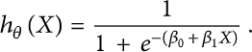

Logistic regression uses a sigmoid function to transform the output to a probability value; the objective is to minimize the cost function to achieve an optimal probability. The cost function is calculated as shown in
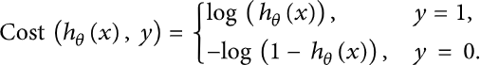

Support Vector Machine

Support vector machine (SVM) is another model for binary classification problem and is available in various kernels functions. The objective of an SVM model is to estimate a hyperplane (or decision boundary) on the basis of feature set to classify data points. The dimension of hyperplane varies according to the number of features. As there could be multiple possibilities for a hyperplane to exist in an N-dimensional space, the task is to identify the plane that separates the data points of two classes with maximum margin. A mathematical representation of the cost function for the SVM model is defined as given in and shown in
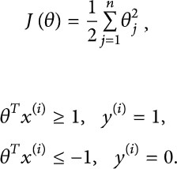

such that
The function above uses a linear kernel. Kernels are usually used to fit data points that cannot be easily separable or data points that are multidimensional. In our case, we have used

sigmoid SVM, kernel SVM (polynomial SVM), Gaussian SVM, and basic linear SVM models.

Multilayer Perceptron

A multilayer perceptron (MLP) is an artificial neural network, with an input layer, one or more hidden layers, and an output layer. MLP can be as simple as having each of the three layers; however, in our experiments we have fine-tuned the model with various parameters and number of layers to generate an optimum predicting model. A basic multilayered perceptron model with one hidden layer can be represented as a function as shown below [31]:
Here, are the bias vectors, are the weight matrices, and and are the activation functions. In our case, the activation function is ReLU and the Adam solver, with 3 hidden layers.

K-Nearest Neighbors (KNN)

KNN is an unsupervised machine learning model where a dependent variable is not required to predict the outcome on a specific data. We provide enough training data to the model and let it decide to which particular neighborhood a data point belongs. KNN model estimates the distance of a new data point to its nearest neighbors, and the value of K estimates the majority of its neighbors’ votes; if the value of K is 1, then the new data point is assigned to a class which has the nearest distance. The mathematical formulae to estimate the distance between two points can be calculated as follows [31]:
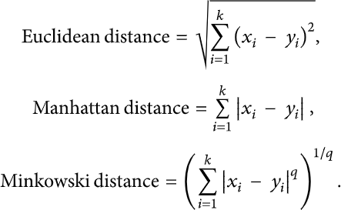

Ensemble Learners

We proposed using existing ensemble techniques along with textual characteristics as feature input to improve the overall accuracy for the purpose of classification between a truthful and a false article. Ensemble learners tend to have higher accuracies, as more than one model is trained using a particular technique to reduce the overall error rate and improve the performance of the model. The intuition behind the ensemble modeling is synonymous to the one we are already used to in our daily life such as requesting opinions of multiple experts before taking a particular decision in order to minimize the chance of a bad decision or an undesirable outcome.
For example, a classification algorithm can be trained on a particular dataset with a unique set of parameters that can produce a decision boundary which fits the data to some extent. The outcome of that particular algorithm depends not only on the parameters that were provided to train the model, but also on the type of training data.
If the training data contains less variance or uniform data, then the model might overfit and produce biased results over unseen data. Therefore, approaches like cross validation are used to minimize the risk of overfitting. A number of models can be trained on different set of parameters to create multiple decision boundaries on randomly chosen data points as training data.
Hence, using ensemble learning techniques, these problems can be addressed and mitigated by training multiple algorithms, and their results can be combined for near optimum outcome. One such technique is using voting classifiers where the final classification depends on the major votes provided by all algorithms [32]. However, there are other ensemble techniques as well that can be used in different scenarios such as the following.

Random Forest (RF)

Random forest (RF) is an advanced form of decision trees (DT) which is also a supervised learning model. RF consists of large number of decision trees working individually to predict an outcome of a class where the final prediction is based on a class that received majority votes. The error rate is low in random forest as compared to other models, due to low correlation among trees [33].
Our random forest model was trained using different parameters; i.e., different numbers of estimators were used in a grid search to produce the best model that can predict the outcome with high accuracy. There are multiple algorithms to decide a split in a decision tree based on the problem of regression or classification. For the classification problem, we have used the Gini index as a cost function to estimate a split in the dataset. The Gini index is calculated by

subtracting the sum of the squared probabilities of each class from one. The mathematical formula to calculate the Gini index () is as follows [34]:

Bagging Ensemble Classifiers

bootstrap aggregating, or in short bagging classifier, is an early ensemble method mainly used to reduce the variance (overfitting) over a training set. Random forest model is one of the most frequently used as a variant of bagging classifier. Intuitively, for a classification problem, the bagging model selects the class on the basis of major votes estimated by number of trees to reduce the overall variance, while the data for each tree is selected using random sampling with replacement from overall dataset. For regression problems, however, the bagging model averages over multiple estimates.

Boosting Ensemble Classifiers

boosting is another widely used ensemble method to train weak models to become strong learners. For that purpose, a forest of randomized trees is trained, and the final prediction is based on the majority vote outcome from each tree.
This method allows weak learners to correctly classify data points in an incremental approach that are usually misclassified. Initially equal weighted coefficients are used for all data points to classify a given problem. In the successive rounds, the weighted coefficients are decreased for data points that are correctly classified and are increased for data points that are misclassified [35].
Each subsequent tree formed in each round learns to reduce the errors from the preceding round and to increase the overall accuracy by correctly classifying data points that were misclassified in previous rounds. One major problem with boosting ensemble is that it might overfit to the training data which may lead to incorrect predictions for unseen instances [36].
There are multiple boosting algorithms available that can be used for both the purposes of classification and regression. In our experiments we used XGBoost [37] and AdaBoost [38] algorithms for classification purpose.

Voting Ensemble Classifiers

voting ensemble is generally used for classification problems as it allows the combination of two or more learning models trained on the whole dataset [39].
Each model predicts an outcome for a sample data point which is considered a “vote” in favor of the class that the model has predicted. Once each model predicts the outcome, the final prediction is based on the majority vote for a specific class [32].

Voting ensemble, as compared to bagging and boosting algorithms, is simpler in terms of implementation. As discussed, bagging algorithms create multiple subsets of data by random sampling and replacement from the whole dataset, thus creating a number of datasets. Each dataset is then used to train a model, while the final result is an aggregation of outcome from each model. In case of boosting, multiple models are trained in a sequential manner where each model learns from the previous by increasing weights for the misclassified points, thus creating a generic model that is able to correctly classify the problem. However, voting ensemble on the other hand is a combination of multiple independent models that produces classification results that contribute to the overall prediction by majority voting.

Benchmark Algorithms

In this section, we discuss the benchmark algorithms with which we compare the performance of our methodology.

Linear SVM

We use linear SVM approach proposed in [21]. To ensure a meaningful comparison, we trained the linear SVM on the feature set as discussed in [21] with 5-fold cross validation. Note that the approach is referred to as Perez-LSVM in the text.

Convolutional Neural Network

Wang [18] used convolutional neural network (CNN) for automatic detection of fake news. We employed the same approach using our dataset. However, we could not use the feature set of Wang [18] as the dataset contains only short statements. The approach is referred to as Wang-CNN in the text.

Performance Metrics

To evaluate the performance of algorithms, we used different metrics. Most of them are based on the confusion matrix. Confusion matrix is a tabular representation of a classification model performance on the test set, which consists of four parameters: true positive, false positive, true negative, and false negative (see Table 1).

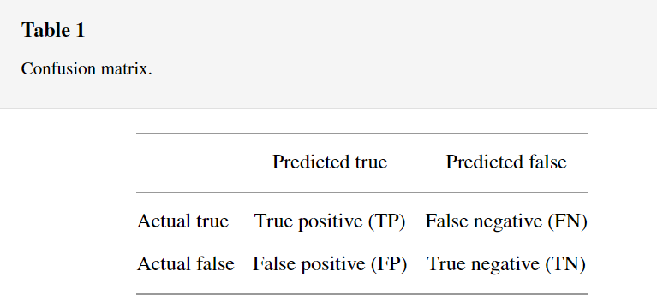

Accuracy

Accuracy is often the most used metric representing the percentage of correctly predicted observations, either true or false. To calculate the accuracy of a model performance, the following equation can be used:
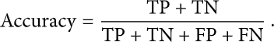

In most cases, high accuracy value represents a good model, but considering the fact that we are training a classification model in our case, an article that was predicted as true while it was actually false (false positive) can have negative consequences; similarly, if an article was predicted as false while it contained factual data, this can create trust issues. Therefore, we have used three other metrics that take into account the incorrectly classified observation, i.e., precision, recall, and F1-score.

Recall

Recall represents the total number of positive classifications out of true class. In our case, it represents the number of articles predicted as true out of the total number of true articles.

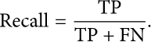

Precision

Conversely, precision score represents the ratio of true positives to all events predicted as true. In our case, precision shows the number of articles that are marked as true out of all the positively predicted (true) articles:
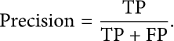

F1-Score

F1-score represents the trade-off between precision and recall. It calculates the harmonic mean between each of the two. Thus, it takes both the false positive and the false negative observations into account. F1-score can be calculated using the following formula:

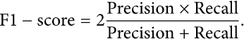

Observed results




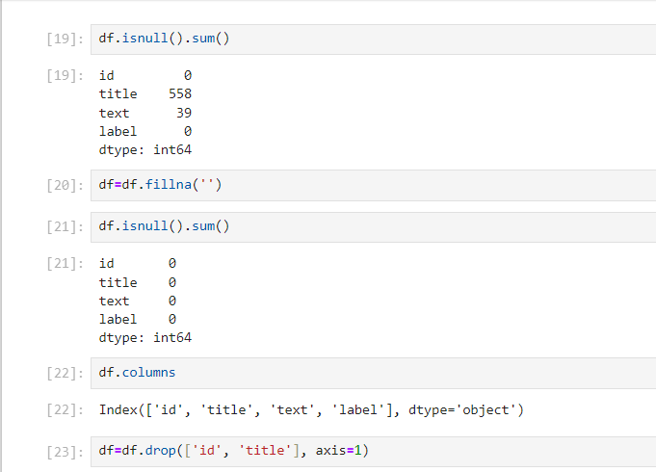

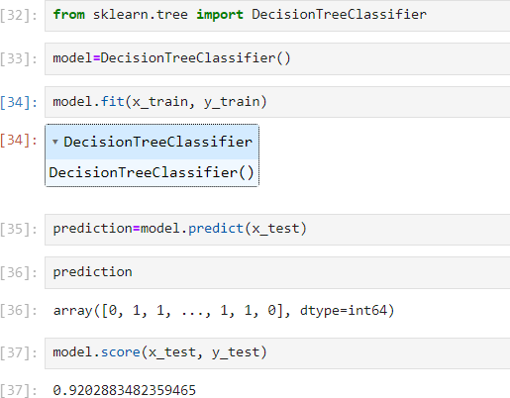

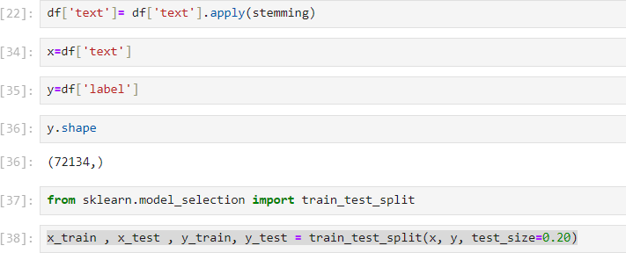

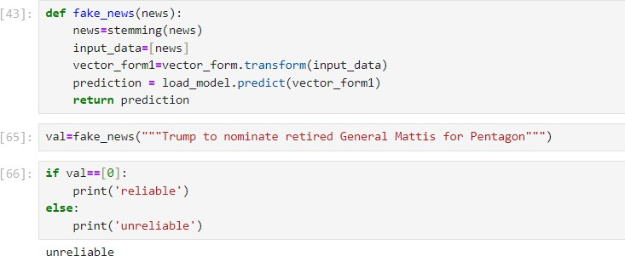

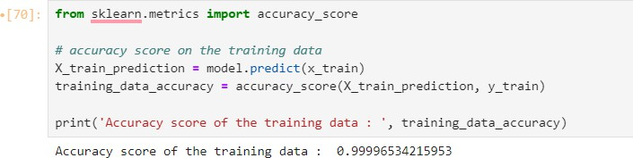



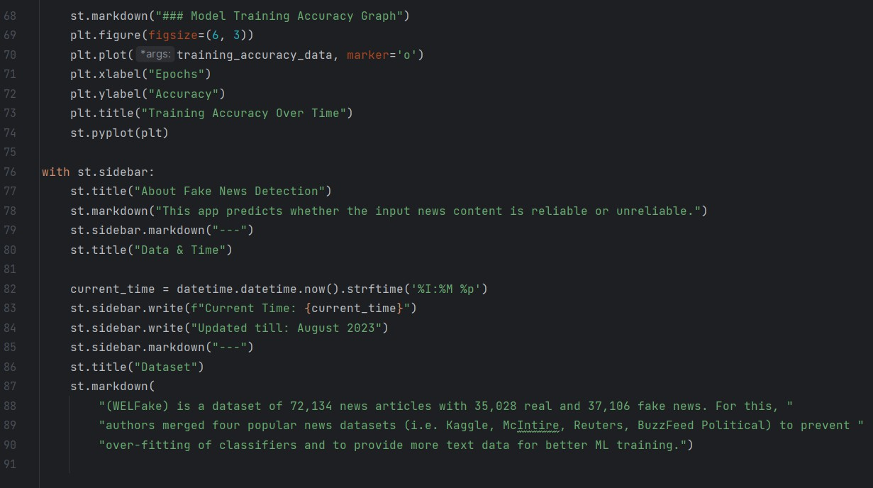





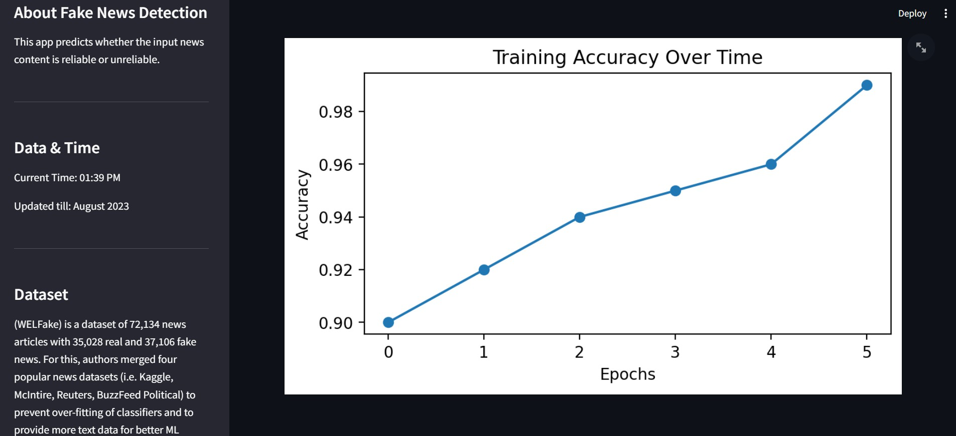

Chapter 5: FUTURE SCOPE

The future of fake news detection holds promising developments driven by advancements in technology and interdisciplinary research. Some potential future scopes include:

- Enhanced Deep Learning Models: The integration of advanced deep learning architectures, including transformer models and graph neural networks, is expected to improve the detection accuracy of fake news by capturing intricate linguistic and semantic nuances in textual data.

- Multimodal Analysis: Future research may focus on integrating multimodal data sources, such as images and videos, to develop comprehensive fake news detection systems capable of analyzing both textual and visual content, thereby enhancing the overall reliability and robustness of the detection process.

- Explainable AI: Emphasis on the development of explainable AI techniques will enable the creation of transparent and interpretable fake news detection models, facilitating a better understanding of the underlying decision-making processes and fostering user trust and confidence in the system's results.

- Blockchain Technology: The integration of blockchain technology may offer potential solutions for establishing immutable and transparent data verification processes, ensuring the traceability and authenticity of news sources and articles, thereby strengthening the credibility and reliability of information in the digital domain.

- Cross-Domain Collaboration: Collaborative efforts between researchers, policymakers, and technology companies will play a pivotal role in developing standardized frameworks and policies for fake news detection, fostering a more coordinated and effective approach to combating the pervasive threat of misinformation across various online platforms and communities.

Chapter 6: CONCLUSION
The advancement of technology and the proliferation of digital information have catalyzed the spread of fake news, posing a significant threat to the integrity of public discourse and societal trust. This project embarked on a comprehensive exploration of fake news detection, leveraging machine learning and natural language processing techniques to develop a robust and effective system for identifying and mitigating the dissemination of misinformation.
Through the meticulous implementation of a decision tree classifier and the integration of various data processing libraries, the project achieved significant milestones in enhancing the accuracy and reliability of the fake news detection process.

The results of the project underscore the critical role of advanced algorithmic techniques and interdisciplinary collaboration in addressing the complexities associated with fake news detection. By employing a decision tree classifier, the system demonstrated its efficacy in discerning between genuine and deceptive information, providing users with a transparent and interpretable framework for evaluating the authenticity of digital content. The utilization of data acquisition and preprocessing libraries facilitated the efficient handling and manipulation of textual data, enabling the extraction of relevant features and attributes crucial for accurate classification.

Furthermore, the incorporation of PyTorch and its dynamic computational graph empowered the system to handle complex neural network architectures and optimize model performance, underscoring the significance of cutting-edge technologies in advancing the capabilities of fake news detection systems. The seamless integration of data visualization and dashboard libraries facilitated the comprehensive analysis and visualization of detection results, enabling users to gain valuable insights into the prevalence and patterns of fake news dissemination.

Looking ahead, the project highlights several avenues for future research and development in the field of fake news detection. The potential integration of blockchain technology and multimodal analysis offers promising prospects for enhancing data integrity and expanding the scope of information verification across diverse content formats. Moreover, the application of explainable AI methodologies holds the key to fostering transparency and trust in the decision-making processes of fake news detection systems, fostering a more informed and vigilant society capable of navigating the digital landscape with greater discernment.

In conclusion, this project serves as a stepping stone in the ongoing efforts to combat the proliferation of fake news and promote responsible information consumption practices. By leveraging the power of machine learning and advanced computational techniques, the project contributes to the establishment of a more transparent and credible information ecosystem, empowering individuals and communities to make well-informed decisions and cultivate a critical approach to online content consumption.

Chapter 7: REFERENCES

- A. Douglas, “News consumption and the new electronic media,” The International Journal of Press/Politics, vol. 11, no. 1, pp. 29–52, 2006.
View at: Publisher Site | Google Scholar
- J. Wong, “Almost all the traffic to fake news sites is from facebook, new data show,” 2016.
View at: Google Scholar
- D. M. J. Lazer, M. A. Baum, Y. Benkler et al., “The science of fake news,” Science, vol. 359, no. 6380, pp. 1094–1096, 2018.
View at: Publisher Site | Google Scholar
- S. A. García, G. G. García, M. S. Prieto, A. J. M. Guerrero, and C. R. Jiménez, “The impact of term fake news on the scientific community scientific performance and mapping in web of science,” Social Sciences, vol. 9, no. 5, 2020.
View at: Google Scholar
- A. D. Holan, 2016 Lie of the Year: Fake News, Politifact, Washington, DC, USA, 2016.
- S. Kogan, T. J. Moskowitz, and M. Niessner, “Fake News: Evidence from Financial Markets,” 2019, https://ssrn.com/abstract=3237763.
View at: Google Scholar
- A. Robb, “Anatomy of a fake news scandal,” Rolling Stone, vol. 1301, pp. 28–33, 2017.
View at: Google Scholar
- J. Soll, “The long and brutal history of fake news,” Politico Magazine, vol. 18, no. 12, 2016.
View at: Google Scholar
- J. Hua and R. Shaw, “Corona virus (covid-19) “infodemic” and emerging issues through a data lens: the case of China,” International Journal of Environmental Research and Public Health, vol. 17, no. 7, p. 2309, 2020.
View at: Publisher Site | Google Scholar
- N. K. Conroy, V. L. Rubin, and Y. Chen, “Automatic deception detection: methods for finding fake news,” Proceedings of the Association for Information Science and

Technology, vol. 52, no. 1, pp. 1–4, 2015.
View at: Publisher Site | Google Scholar
- F. T. Asr and M. Taboada, “Misinfotext: a collection of news articles, with false and true labels,” 2019.
View at: Google Scholar
- K. Shu, A. Sliva, S. Wang, J. Tang, and H. Liu, “Fake news detection on social media,” ACM SIGKDD Explorations Newsletter, vol. 19, no. 1, pp. 22–36, 2017.
View at: Publisher Site | Google Scholar
- S. Vosoughi, D. Roy, and S. Aral, “The spread of true and false news online,”
Science, vol. 359, no. 6380, pp. 1146–1151, 2018.
View at: Publisher Site | Google Scholar
- H. Allcott and M. Gentzkow, “Social media and fake news in the 2016 election,”
Journal of Economic Perspectives, vol. 31, no. 2, pp. 211–236, 2017.
View at: Publisher Site | Google Scholar
- V. L. Rubin, N. Conroy, Y. Chen, and S. Cornwell, “Fake news or truth? using satirical cues to detect potentially misleading news,” in Proceedings of the Second Workshop on Computational Approaches to Deception Detection, pp. 7–17, San Diego, CA, USA, 2016.
View at: Google Scholar
- H. Jwa, D. Oh, K. Park, J. M. Kang, and H. Lim, “exBAKE: automatic fake news detection model based on bidirectional encoder representations from transformers (bert),” Applied Sciences, vol. 9, no. 19, 2019.
View at: Publisher Site | Google Scholar
- H. Ahmed, I. Traore, and S. Saad, “Detection of online fake news using n-gram analysis and machine learning techniques,” in Proceedings of the International
Conference on Intelligent, Secure, and Dependable Systems in Distributed and Cloud Environments, pp. 127–138, Springer, Vancouver, Canada, 2017.
View at: Publisher Site | Google Scholar
- W. Y. Wang, Liar, Liar Pants on Fire: A New Benchmark Dataset for Fake News Detection, Association for Computational Linguistics, Stroudsburg, PA, USA, 2017.
- B. Riedel, I. Augenstein, G. P. Spithourakis, and S. Riedel, “A simple but tough-to-beat baseline for the fake news challenge stance detection task,” 2017,

https://arxiv.org/abs/1707.03264.
View at: Google Scholar
- N. Ruchansky, S. Seo, and Y. Liu, “Csi: a hybrid deep model for fake news detection,” in Proceedings of the 2017 ACM on Conference on Information and Knowledge Management, pp. 797–806, Singapore, 2017.
View at: Google Scholar
- V. Pérez-Rosas, B. Kleinberg, A. Lefevre, and R. Mihalcea, “Automatic detection of fake news,” 2017, https://arxiv.org/abs/1708.07104.
View at: Google Scholar
- P. Bühlmann, “Bagging, boosting and ensemble methods,” in Handbook of Computational Statistics, pp. 985–1022, Springer, Berlin, Germany, 2012.
View at: Google Scholar
- H. Ahmed, I. Traore, and S. Saad, “Detecting opinion spams and fake news using text classification,” Security and Privacy, vol. 1, no. 1, 2018.
View at: Publisher Site | Google Scholar
- Kaggle, Fake News, Kaggle, San Francisco, CA, USA, 2018, https://www.kaggle.com/c/fake-news.
- Kaggle, Fake News Detection, Kaggle, San Francisco, CA, USA, 2018, https://www.kaggle.com/jruvika/fake-news-detection.
- J. Bergstra and Y. Bengio, “Random search for hyper-parameter optimization,”
Journal of Machine Learning Research, vol. 13, pp. 281–305, 2012.
View at: Google Scholar
- T. M. Mitchell, The Discipline of Machine Learning, Carnegie Mellon University, Pittsburgh, PA, USA, 2006.
- N. Cristianini and J. Shawe-Taylor, An Introduction to Support Vector Machines and Other Kernel-Based Learning Methods, Cambridge University Press, Cambridge, UK, 2000.
- T. Hofmann, B. Schölkopf, and A. J. Smola, “Kernel methods in machine learning,” The Annals of Statistics, vol. 36, no. 3, pp. 1171–1220, 2008.
View at: Publisher Site | Google Scholar
- V. Kecman, Support Vector Machines-An Introduction in “Support Vector Machines: Theory and Applications”, Springer, New York City, NY, USA, 2005.

